este es el orden: auth users companies analysis route-engine question-engine knowledge-base score-engine red-flag-engine confidence-engine recommendation-engine report-engine simulation-engine market-intelligence copilot
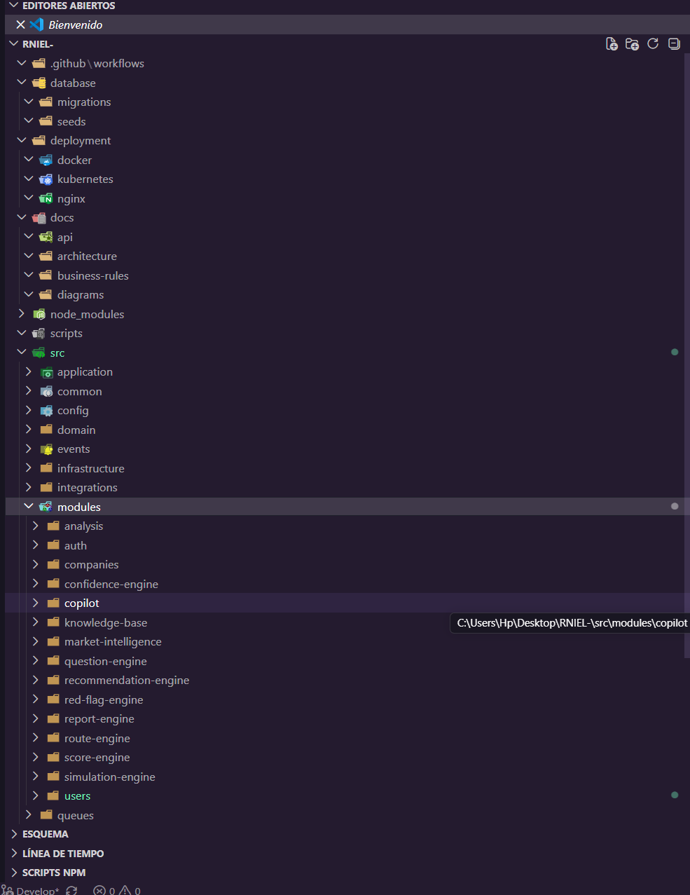
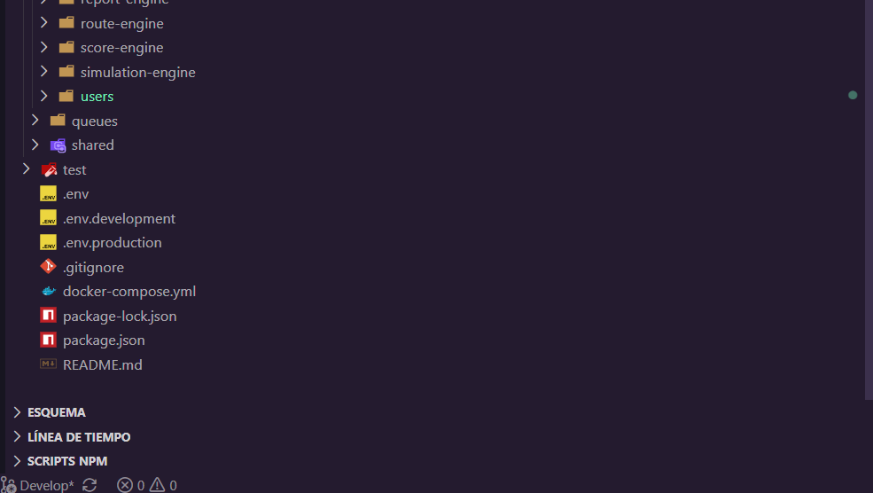

Perfecto. Empecemos por los primeros archivos reales de auth. Estos sí están listos para copiar y pegar.

src/modules/auth/constants/auth.constants.ts
export const AUTH_CONSTANTS = {
ACCESS_TOKEN_EXPIRATION: '15m',
REFRESH_TOKEN_EXPIRATION: '7d',
BCRYPT_ROUNDS: 10,
} as const;

src/modules/auth/interfaces/jwt-payload.interface.ts
export interface JwtPayload {
sub: string;
email: string;
role: string;
companyId?: string;
}

src/modules/auth/interfaces/authenticated-user.interface.ts
export interface AuthenticatedUser {
id: string;
email: string;
role: string;
companyId?: string;
}

src/modules/auth/dto/login.dto.ts
Si aún no has instalado class-validator:
npm install class-validator class-transformer
Código:
import { IsEmail, IsNotEmpty, IsString } from 'class-validator';

export class LoginDto {
@IsEmail()
email: string;

@IsString()
@IsNotEmpty()
password: string;
}

src/modules/auth/dto/register.dto.ts
import {
IsEmail,
IsNotEmpty,
IsOptional,
IsString,
MinLength,
} from 'class-validator';

export class RegisterDto {
@IsString()
@IsNotEmpty()
name: string;

@IsEmail()
email: string;

@MinLength(8)
password: string;

@IsOptional()
@IsString()
companyId?: string;
}

src/modules/auth/dto/refresh-token.dto.ts
import { IsNotEmpty, IsString } from 'class-validator';

export class RefreshTokenDto {
@IsString()
@IsNotEmpty()
refreshToken: string;
}

src/modules/auth/dto/auth-response.dto.ts
export class AuthResponseDto {
accessToken: string;

refreshToken: string;

expiresIn: number;

user: {
id: string;
name: string;
email: string;
role: string;
};
}

src/modules/auth/mappers/auth.mapper.ts
import { AuthResponseDto } from '../dto/auth-response.dto';

export class AuthMapper {
static toAuthResponse(
user: any,
accessToken: string,
refreshToken: string,
expiresIn: number,
): AuthResponseDto {
return {
accessToken,
refreshToken,
expiresIn,
user: {
id: user.id,
name: user.name,
email: user.email,
role: user.role,
},
};
}
}

src/modules/auth/guards/auth.guard.ts
import { Injectable } from '@nestjs/common';
import { AuthGuard as PassportAuthGuard } from '@nestjs/passport';

@Injectable()
export class AuthGuard extends PassportAuthGuard('jwt') {}

src/modules/auth/strategies/jwt.strategy.ts
import { Injectable } from '@nestjs/common';
import { PassportStrategy } from '@nestjs/passport';
import { ExtractJwt, Strategy } from 'passport-jwt';
import { ConfigService } from '@nestjs/config';

import { JwtPayload } from '../interfaces/jwt-payload.interface';

@Injectable()
export class JwtStrategy extends PassportStrategy(Strategy) {
constructor(private readonly configService: ConfigService) {
super({
jwtFromRequest: ExtractJwt.fromAuthHeaderAsBearerToken(),
ignoreExpiration: false,
secretOrKey: configService.get<string>('JWT_SECRET'),
});
}

async validate(payload: JwtPayload) {
return {
id: payload.sub,
email: payload.email,
role: payload.role,
companyId: payload.companyId,
};
}
}

Con esto ya puedes hacer un commit serio:
git add .
git commit -m "feat(auth): add dto interfaces constants mapper and jwt strategy"
git push origin Develop
El siguiente bloque sería:
auth.service.ts
auth.controller.ts
auth.module.ts
pero esos dependen de cómo vamos a implementar users, UserRepository y Prisma, así que prefiero construirlos correctamente en lugar de inventar dependencias que mañana tendremos que reescribir.

// src/modules/users/dto/create-user.dto.ts

import {
IsEmail,
IsNotEmpty,
IsOptional,
IsString,
MinLength,
} from 'class-validator';

export class CreateUserDto {
@IsString()
@IsNotEmpty()
name: string;

@IsEmail()
email: string;

@MinLength(8)
password: string;

@IsOptional()
@IsString()
companyId?: string;
}
// src/modules/users/dto/update-user.dto.ts

import {
IsEmail,
IsOptional,
IsString,
MinLength,
} from 'class-validator';

export class UpdateUserDto {
@IsOptional()
@IsString()
name?: string;

@IsOptional()
@IsEmail()
email?: string;

@IsOptional()
@MinLength(8)
password?: string;

@IsOptional()
@IsString()
companyId?: string;
}
// src/modules/users/dto/user-response.dto.ts

export class UserResponseDto {
id: string;
name: string;
email: string;
role: string;
companyId?: string | null;
createdAt: Date;
}
// src/modules/users/interfaces/user.interface.ts

export interface User {
id: string;
name: string;
email: string;
password: string;
role: string;
companyId?: string | null;
createdAt: Date;
updatedAt: Date;
}
// src/modules/users/mappers/user.mapper.ts

import { UserResponseDto } from '../dto/user-response.dto';

export class UserMapper {
static toResponse(user: any): UserResponseDto {
return {
id: user.id,
name: user.name,
email: user.email,
role: user.role,
companyId: user.companyId,
createdAt: user.createdAt,
};
}

static toResponseList(users: any[]): UserResponseDto[] {
return users.map((user) => this.toResponse(user));
}
}
// src/modules/users/repositories/user.repository.ts

import { Injectable } from '@nestjs/common';
import { PrismaService } from '../../../shared/database/prisma.service';

@Injectable()
export class UserRepository {
constructor(private readonly prisma: PrismaService) {}

async create(data: any) {
return this.prisma.user.create({
data,
});
}

async findAll() {
return this.prisma.user.findMany({
orderBy: {
createdAt: 'desc',
},
});
}

async findById(id: string) {
return this.prisma.user.findUnique({
where: { id },
});
}

async findByEmail(email: string) {
return this.prisma.user.findUnique({
where: { email },
});
}

async update(id: string, data: any) {
return this.prisma.user.update({
where: { id },
data,
});
}

async delete(id: string) {
return this.prisma.user.delete({
where: { id },
});
}
}
// src/modules/users/users.service.ts

import {
ConflictException,
Injectable,
NotFoundException,
} from '@nestjs/common';
import * as bcrypt from 'bcrypt';

import { CreateUserDto } from './dto/create-user.dto';
import { UpdateUserDto } from './dto/update-user.dto';
import { UserRepository } from './repositories/user.repository';

@Injectable()
export class UsersService {
constructor(
private readonly userRepository: UserRepository,
) {}

async create(createUserDto: CreateUserDto) {
const existingUser = await this.userRepository.findByEmail(
createUserDto.email,
);

if (existingUser) {
throw new ConflictException('User already exists');
}

const hashedPassword = await bcrypt.hash(
createUserDto.password,
10,
);

return this.userRepository.create({
...createUserDto,
password: hashedPassword,
role: 'CLIENTE',
});
}

async findAll() {
return this.userRepository.findAll();
}

async findById(id: string) {
const user = await this.userRepository.findById(id);

if (!user) {
throw new NotFoundException('User not found');
}

return user;
}

async findByEmail(email: string) {
return this.userRepository.findByEmail(email);
}

async update(
id: string,
updateUserDto: UpdateUserDto,
) {
await this.findById(id);

const payload: any = {
...updateUserDto,
};

if (updateUserDto.password) {
payload.password = await bcrypt.hash(
updateUserDto.password,
10,
);
}

return this.userRepository.update(id, payload);
}

async remove(id: string) {
await this.findById(id);

return this.userRepository.delete(id);
}
}
// src/modules/users/users.controller.ts

import {
Body,
Controller,
Delete,
Get,
Param,
Patch,
Post,
} from '@nestjs/common';

import { CreateUserDto } from './dto/create-user.dto';
import { UpdateUserDto } from './dto/update-user.dto';
import { UserMapper } from './mappers/user.mapper';
import { UsersService } from './users.service';

@Controller('users')
export class UsersController {
constructor(
private readonly usersService: UsersService,
) {}

@Post()
async create(@Body() dto: CreateUserDto) {
const user = await this.usersService.create(dto);

return UserMapper.toResponse(user);
}

@Get()
async findAll() {
const users = await this.usersService.findAll();

return UserMapper.toResponseList(users);
}

@Get(':id')
async findOne(@Param('id') id: string) {
const user = await this.usersService.findById(id);

return UserMapper.toResponse(user);
}

@Patch(':id')
async update(
@Param('id') id: string,
@Body() dto: UpdateUserDto,
) {
const user = await this.usersService.update(
id,
dto,
);

return UserMapper.toResponse(user);
}

@Delete(':id')
async remove(@Param('id') id: string) {
return this.usersService.remove(id);
}
}
// src/modules/users/users.module.ts

import { Module } from '@nestjs/common';

import { UsersController } from './users.controller';
import { UsersService } from './users.service';
import { UserRepository } from './repositories/user.repository';

@Module({
controllers: [UsersController],
providers: [
UsersService,
UserRepository,
],
exports: [
UsersService,
UserRepository,
],
})
export class UsersModule {}
// prisma/models/user.prisma

model User {
id String @id @default(uuid())
name String
email String @unique
password String
role String @default("CLIENTE")
companyId String?
company Company? @relation(fields: [companyId], references: [id])

createdAt DateTime @default(now())
updatedAt DateTime @updatedAt

analyses Analysis[]

@@map("users")
}
// src/modules/companies/dto/create-company.dto.ts

import { IsNotEmpty, IsOptional, IsString } from 'class-validator';

export class CreateCompanyDto {
@IsString()
@IsNotEmpty()
name: string;

@IsOptional()
@IsString()
description?: string;
}
// src/modules/companies/dto/update-company.dto.ts

import { IsOptional, IsString } from 'class-validator';

export class UpdateCompanyDto {
@IsOptional()
@IsString()
name?: string;

@IsOptional()
@IsString()
description?: string;
}
// src/modules/companies/dto/company-response.dto.ts

export class CompanyResponseDto {
id: string;
name: string;
description?: string | null;
createdAt: Date;
}
// src/modules/companies/interfaces/company.interface.ts

export interface Company {
id: string;
name: string;
description?: string | null;
createdAt: Date;
updatedAt: Date;
}
// src/modules/companies/mappers/company.mapper.ts

import { CompanyResponseDto } from '../dto/company-response.dto';

export class CompanyMapper {
static toResponse(company: any): CompanyResponseDto {
return {
id: company.id,
name: company.name,
description: company.description,
createdAt: company.createdAt,
};
}

static toResponseList(companies: any[]): CompanyResponseDto[] {
return companies.map((company) => this.toResponse(company));
}
}
// src/modules/companies/repositories/company.repository.ts

import { Injectable } from '@nestjs/common';
import { PrismaService } from '../../../shared/database/prisma.service';

@Injectable()
export class CompanyRepository {
constructor(
private readonly prisma: PrismaService,
) {}

async create(data: any) {
return this.prisma.company.create({
data,
});
}

async findAll() {
return this.prisma.company.findMany({
orderBy: {
createdAt: 'desc',
},
});
}

async findById(id: string) {
return this.prisma.company.findUnique({
where: { id },
});
}

async update(id: string, data: any) {
return this.prisma.company.update({
where: { id },
data,
});
}

async delete(id: string) {
return this.prisma.company.delete({
where: { id },
});
}
}
// src/modules/companies/companies.service.ts

import {
Injectable,
NotFoundException,
} from '@nestjs/common';

import { CreateCompanyDto } from './dto/create-company.dto';
import { UpdateCompanyDto } from './dto/update-company.dto';
import { CompanyRepository } from './repositories/company.repository';

@Injectable()
export class CompaniesService {
constructor(
private readonly companyRepository: CompanyRepository,
) {}

async create(dto: CreateCompanyDto) {
return this.companyRepository.create(dto);
}

async findAll() {
return this.companyRepository.findAll();
}

async findById(id: string) {
const company = await this.companyRepository.findById(id);

if (!company) {
throw new NotFoundException('Company not found');
}

return company;
}

async update(
id: string,
dto: UpdateCompanyDto,
) {
await this.findById(id);

return this.companyRepository.update(id, dto);
}

async remove(id: string) {
await this.findById(id);

return this.companyRepository.delete(id);
}
}
// src/modules/companies/companies.controller.ts

import {
Body,
Controller,
Delete,
Get,
Param,
Patch,
Post,
} from '@nestjs/common';

import { CompaniesService } from './companies.service';
import { CompanyMapper } from './mappers/company.mapper';
import { CreateCompanyDto } from './dto/create-company.dto';
import { UpdateCompanyDto } from './dto/update-company.dto';

@Controller('companies')
export class CompaniesController {
constructor(
private readonly companiesService: CompaniesService,
) {}

@Post()
async create(
@Body() dto: CreateCompanyDto,
) {
const company =
await this.companiesService.create(dto);

return CompanyMapper.toResponse(company);
}

@Get()
async findAll() {
const companies =
await this.companiesService.findAll();

return CompanyMapper.toResponseList(companies);
}

@Get(':id')
async findOne(
@Param('id') id: string,
) {
const company =
await this.companiesService.findById(id);

return CompanyMapper.toResponse(company);
}

@Patch(':id')
async update(
@Param('id') id: string,
@Body() dto: UpdateCompanyDto,
) {
const company =
await this.companiesService.update(id, dto);

return CompanyMapper.toResponse(company);
}

@Delete(':id')
async remove(
@Param('id') id: string,
) {
return this.companiesService.remove(id);
}
}
// src/modules/companies/companies.module.ts

import { Module } from '@nestjs/common';

import { CompaniesController } from './companies.controller';
import { CompaniesService } from './companies.service';
import { CompanyRepository } from './repositories/company.repository';

@Module({
controllers: [CompaniesController],
providers: [
CompaniesService,
CompanyRepository,
],
exports: [
CompaniesService,
CompanyRepository,
],
})
export class CompaniesModule {}
// prisma/models/company.prisma

model Company {
id String @id @default(uuid())
name String
description String?

users User[]

createdAt DateTime @default(now())
updatedAt DateTime @updatedAt

@@map("companies")
}
// prisma/models/user.prisma

model User {
id String @id @default(uuid())
name String
email String @unique
password String
role String @default("CLIENTE")

companyId String?
company Company? @relation(fields: [companyId], references: [id])

createdAt DateTime @default(now())
updatedAt DateTime @updatedAt

@@map("users")
}
git add .
git commit -m "feat(companies): add companies module with prisma relation"
git push origin Develop
Siguiente módulo:
analysis
Ahí ya empezamos con el núcleo real de AUM PRO.

// prisma/models/analysis.prisma

enum AnalysisStatus {
DRAFT
IN_PROGRESS
COMPLETED
ARCHIVED
}

model Analysis {
id String @id @default(uuid())

title String?
objective String?
analysisType String?
status AnalysisStatus @default(DRAFT)

userId String
user User @relation(fields: [userId], references: [id])

createdAt DateTime @default(now())
updatedAt DateTime @updatedAt

@@map("analyses")
}
// prisma/models/user.prisma

model User {
id String @id @default(uuid())
name String
email String @unique
password String
role String @default("CLIENTE")

companyId String?
company Company? @relation(fields: [companyId], references: [id])

analyses Analysis[]

createdAt DateTime @default(now())
updatedAt DateTime @updatedAt

@@map("users")
}
// src/modules/analysis/dto/create-analysis.dto.ts

import {
IsOptional,
IsString,
} from 'class-validator';

export class CreateAnalysisDto {
@IsOptional()
@IsString()
title?: string;

@IsOptional()
@IsString()
objective?: string;

@IsOptional()
@IsString()
analysisType?: string;

@IsString()
userId: string;
}
// src/modules/analysis/dto/update-analysis.dto.ts

import {
IsOptional,
IsString,
} from 'class-validator';

export class UpdateAnalysisDto {
@IsOptional()
@IsString()
title?: string;

@IsOptional()
@IsString()
objective?: string;

@IsOptional()
@IsString()
analysisType?: string;

@IsOptional()
@IsString()
status?: string;
}
// src/modules/analysis/dto/analysis-response.dto.ts

export class AnalysisResponseDto {
id: string;
title?: string | null;
objective?: string | null;
analysisType?: string | null;
status: string;
userId: string;
createdAt: Date;
}
// src/modules/analysis/interfaces/analysis.interface.ts

export interface Analysis {
id: string;
title?: string | null;
objective?: string | null;
analysisType?: string | null;
status: string;
userId: string;
createdAt: Date;
updatedAt: Date;
}
// src/modules/analysis/mappers/analysis.mapper.ts

import { AnalysisResponseDto } from '../dto/analysis-response.dto';

export class AnalysisMapper {
static toResponse(
analysis: any,
): AnalysisResponseDto {
return {
id: analysis.id,
title: analysis.title,
objective: analysis.objective,
analysisType: analysis.analysisType,
status: analysis.status,
userId: analysis.userId,
createdAt: analysis.createdAt,
};
}

static toResponseList(
analyses: any[],
): AnalysisResponseDto[] {
return analyses.map((analysis) =>
this.toResponse(analysis),
);
}
}
// src/modules/analysis/repositories/analysis.repository.ts

import { Injectable } from '@nestjs/common';
import { PrismaService } from '../../../shared/database/prisma.service';

@Injectable()
export class AnalysisRepository {
constructor(
private readonly prisma: PrismaService,
) {}

async create(data: any) {
return this.prisma.analysis.create({
data,
});
}

async findAll() {
return this.prisma.analysis.findMany({
orderBy: {
createdAt: 'desc',
},
});
}

async findById(id: string) {
return this.prisma.analysis.findUnique({
where: { id },
});
}

async update(
id: string,
data: any,
) {
return this.prisma.analysis.update({
where: { id },
data,
});
}

async delete(id: string) {
return this.prisma.analysis.delete({
where: { id },
});
}
}
// src/modules/analysis/analysis.service.ts

import {
Injectable,
NotFoundException,
} from '@nestjs/common';

import { AnalysisRepository } from './repositories/analysis.repository';
import { CreateAnalysisDto } from './dto/create-analysis.dto';
import { UpdateAnalysisDto } from './dto/update-analysis.dto';

@Injectable()
export class AnalysisService {
constructor(
private readonly analysisRepository: AnalysisRepository,
) {}

async create(
dto: CreateAnalysisDto,
) {
return this.analysisRepository.create({
...dto,
status: 'DRAFT',
});
}

async findAll() {
return this.analysisRepository.findAll();
}

async findById(id: string) {
const analysis =
await this.analysisRepository.findById(id);

if (!analysis) {
throw new NotFoundException(
'Analysis not found',
);
}

return analysis;
}

async update(
id: string,
dto: UpdateAnalysisDto,
) {
await this.findById(id);

return this.analysisRepository.update(
id,
dto,
);
}

async remove(id: string) {
await this.findById(id);

return this.analysisRepository.delete(id);
}
}
// src/modules/analysis/analysis.controller.ts

import {
Body,
Controller,
Delete,
Get,
Param,
Patch,
Post,
} from '@nestjs/common';

import { AnalysisService } from './analysis.service';
import { AnalysisMapper } from './mappers/analysis.mapper';
import { CreateAnalysisDto } from './dto/create-analysis.dto';
import { UpdateAnalysisDto } from './dto/update-analysis.dto';

@Controller('analysis')
export class AnalysisController {
constructor(
private readonly analysisService: AnalysisService,
) {}

@Post()
async create(
@Body() dto: CreateAnalysisDto,
) {
const analysis =
await this.analysisService.create(dto);

return AnalysisMapper.toResponse(
analysis,
);
}

@Get()
async findAll() {
const analyses =
await this.analysisService.findAll();

return AnalysisMapper.toResponseList(
analyses,
);
}

@Get(':id')
async findOne(
@Param('id') id: string,
) {
const analysis =
await this.analysisService.findById(id);

return AnalysisMapper.toResponse(
analysis,
);
}

@Patch(':id')
async update(
@Param('id') id: string,
@Body() dto: UpdateAnalysisDto,
) {
const analysis =
await this.analysisService.update(
id,
dto,
);

return AnalysisMapper.toResponse(
analysis,
);
}

@Delete(':id')
async remove(
@Param('id') id: string,
) {
return this.analysisService.remove(id);
}
}
// src/modules/analysis/analysis.module.ts

import { Module } from '@nestjs/common';

import { AnalysisController } from './analysis.controller';
import { AnalysisService } from './analysis.service';
import { AnalysisRepository } from './repositories/analysis.repository';

@Module({
controllers: [AnalysisController],
providers: [
AnalysisService,
AnalysisRepository,
],
exports: [
AnalysisService,
AnalysisRepository,
],
})
export class AnalysisModule {}
git add .
git commit -m "feat(analysis): add analysis module and domain model"
git push origin Develop
Siguiente módulo:
route-engine
Ese ya es el primer motor inteligente de AUM PRO y donde empieza la detección automática de rutas (IDEA_NEGOCIO, INVERSION, FRANQUICIA, ACTIVO_DIGITAL, etc.).

